**COMSATS UNIVERSITY ISLAMABAD**

**ATTOCK CAMPUS**

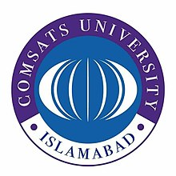

Assignment No : 2

**SUBMITTED TO : Sir Kamran**

**SUBMITTED BY : Umar Abdul Rehman**

**REGISTRATION # : Sp18-mcs-008**

**Date : 25-04-2019**

HERO

